**PSTU Enrollment Automation System Using Django Framework and SQLite**

by

Md. Tasnif Rahman

Mehedi Hasan Rabbi

PROJECT SUBMITTED IN FULLFILLMENT OF THE DEGREE OF BACHELOR OF SCIENCE IN COMPUTER SCIENCE & ENGINEERING



FACULTY OF COMPUTER SCIENCE & ENGINEERING

PATUAKHALI SCIENCE & TECHNOLOGY UNIVERSITY

27th March, 2024

**DECLARATION OF ORIGINAL WORK**

The project titled “PSTU Enrollment Automation Website Using Django Framework and SQLite”, submitted by Md. Tasnif Rahman, Roll No. **1802014**, Session: 2018-19 and Mehedi Hasan Rabbi, Roll No. **1802052**, Session: 2018-19 to the Faculty of Computer Science and Engineering, Patuakhali Science & Technology University, has been accepted as satisfactory for the fulfilment of the requirements for the degree of Bachelor of Science in Computer Science & Engineering and approved as to its style and contents.

**Board of Examinee**

|  |  |
| --- | --- |
| Signature  Supervisor & Chairman of the ECC  Dept. Name  Faculty Name | : ______________________________  : Professor Golam Md. Muradul Bashir  : Dept. of Computer and Communication Engineering  : Faculty of Computer Science and Engineering |
|  |  |
| Signature  Name of Internal Member  Dept. Name  Faculty Name | : ______________________________  : Professor Dr. Md. Samsuzzaman  : Dept. of Computer and Communication Engineering  : Faculty of Computer Science and Engineering |
|  |  |
| Signature  Name of Internal Member  Dept. Name  Faculty Name | : ______________________________  : Assistant Professor Sarna Majumder  : Dept. of Computer and Communication Engineering  : Faculty of Computer Science and Engineering |
|  |  |
| Signature  Name of Internal Member  Dept. Name  Faculty Name | : ______________________________  : Assistant Professor Arpita Howlader  : Dept. of Computer and Communication Engineering  : Faculty of Computer Science and Engineering |
|  |  |
| Signature  Name of External Member  Dept. Name  Faculty Name | : ______________________________  : Assistant Professor Md. Mahbubur Rahman  : Dept. of Computer Science and Information Technology  : Faculty of Computer Science and Engineering |
|  |  |
| Signature  Dean Faculty of CSE | : ______________________________  : Professor Dr. Md. Bellal Hossain |

Patuakhali Science and Technology University, Bangladesh

**Certificate**

This is to certify that this is a record of the project presented by the students whose names are given below in fulfillment of the requirements of the degree of Bachelor of Science in Computer Science and Engineering.

|  |  |
| --- | --- |
| **Md. Tasnif Rahman**  ID: 1802014  Reg. No: 08424  Session: 2018-19 | **Mehedi Hasan Rabbi**  ID: 1802052  Reg. No: 08462  Session: 2018-19 |

**Supervised By**

**Golam Md. Muradul Bashir**

Professor (Active)

Department of Computer and Communication Engineering

Faculty of Computer Science & Engineering

Patuakhali Science & Technology University

**Manash Sarker**

Assistant Professor (On Leave)

Department of Computer and Communication Engineering

Faculty of Computer Science & Engineering

Patuakhali Science & Technology University

**DEDICATION**

We dedicate this project to Allah Almighty our creator, our strong pillar, our source of inspiration, wisdom, knowledge and understanding. We dedicate my dissertation work to my family and many friends.

**Letter of Approval**

This Project Submitted by Md. Tasnif Rahman bearing ID No. 1802014, Mehedi Hasan Rabbi bearing ID No. 1802052 in partial fulfillment of Final Project Submission for B.Sc. in CSE degree has been examined and accepted for further process.

**Approved**

**………………………………**

**Golam Md. Muradul Bashir**

Professor

Department of Computer and Communication Engineering

Faculty of Computer Science & Engineering

Patuakhali Science & Technology University

**ABSTRACT**

The PSTU Enrollment project is a comprehensive upgrade of Patuakhali Science and Technology University's enrollment system. It aims to simplify and enhance the enrollment process for students while providing administrators with efficient management tools. This system offers three-tier authentication for administrators, faculty, and students, granting access to relevant features. Administrators have full control over administrative tasks, faculty members can manage courses and advice, and students can apply, register, and view academic records. Built with Django and powered by Python, PSTU Enrollment features a user-friendly interface and includes functions such as course management, faculty administration, and student profiles. Rigorous testing ensures reliability and security, aligning with university standards. PSTU Enrollment promises streamlined workflows, improved communication, and a better student experience. With potential for future expansion, it serves as a valuable asset for PSTU's enrollment management and sets the stage for further advancements in student services.

**ACKNOWLEDGMENTS**

At first we are thankful to almighty Allah. He blesses us to complete this project successfully and also deliver this within deadline.

The satisfaction that accompanies that the successful completion of any task would be incomplete without the mention of people whose ceaseless cooperation made it possible, whose constant guidance and encouragement crown all efforts with success.

We are also grateful to our supervisor Golam Md. Muradul Bashir, Professor, Department of Computer and Communication Engineering, Faculty of Computer Science & Engineering, Patuakhali Science & Technology University.

We also grateful to CSE 16th batch, Patuakhali Science & Technology University.

With Best Regards,

Md. Tasnif Rahman

Mehedi Hasan Rabbi

**DECLARATION**

We declare that the work presented in this “PSTU Enrollment Automation Website Using Django Framework and SQLite” submitted to the Patuakhali Science and Technology University, for the award of the Bachelor of Science in Computer Science and Engineering degree, is our original work. We have not plagiarized or submitted the same work for the award of any other degree. In-case this undertaking is found incorrect, I accept that my degree may be unconditionally withdrawn.

|  |  |
| --- | --- |
| ………………………………….  Md. Tasnif Rahman | ………………………………….  Mehedi Hasan Rabbi |

**Table of Contents**

**LIST OF FIGURES xiii**

**CHAPTER-1 1**

**1. INTRODUCTION 1**

1.1 Introduction 1

1.2 Motivation 1

1.3 Existing System 2

1.4 Updated System 3

1.5 Contributions 3

1.6 Objectives 4

1.7 Organization of Project Reports 4

1.8 Summary 4

**CHAPTER-2 5**

**2. LITERATURE REVIEW OF PROJECT 5**

2.1 Introduction 5

2.2 Literature Review 5

2.3 Similar System 5

2.3 Comparisons with our System 5

2.4 Summary 6

**CHAPTER-3 6**

**3. METHODOLOGY 6**

3.1 Introduction of Methodology 6

3.2 Facts finding techniques 6

3.3 Software Development Life Cycle (SDLC) 6

3.3.1 Software process model 7

3.3.2 Feasibility Study 7

3.3.3 Technical Feasibility 7

3.3.4 Operational Feasibility 8

3.3.5. Economic Feasibility 8

3.4 Summary 8

**CHAPTER-4** 9

**4.** **DATABASE DESIGN** 9

4.1 Database Design 9

4.2 Entity Relationship Diagram 9

4.2.1 PSTU Enrollment ER Diagram 9

4.3 Summary 10

**CHAPTER-5** 10

**5.** **SOFTWARE DESIGN** 10

5.1 Introduction 10

5.2 Overall design 10

5.2.1 Admin Panel 10

5.2.2 Student Account Create and Delete 11

5.2.3 Course Add and Delete 11

5.2.4 Student Dashboard 11

5.2.5 Next Semester Course List 12

5.2.6 Payment Page Design 12

5.3 Summary 12

**CHAPTER-6** 13

**6.** **TESTING AND SEQURITY** 13

6.1 Introduction 13

6.2 Research Objective & Development Approach of Agile Methods 13

6.2.1 Test Automation 14

6.2.2 Regression Tests 14

6.3 Summary 14

**CHAPTER-7** 15

**7.** **CONCLUSION** 15

7.1 Introduction 15

7.2 Project Outcomes 15

7.3 Future Works 15

7.4 Summary 15

**References** 16

# **LIST OF FIGURES**

Figure 1: PSTU Enrollment System ER Diagram 9

Figure 2: Admin Panel 10

Figure 3: Student Account Create and Student List 11

Figure 4: Course Add and Delete 11

Figure 5: Student Dashboard 11

Figure 6: Next Semester Course List 12

Figure 7: Payment Page Design 12

# **CHAPTER-1**

# **INTRODUCTION**

## **Introduction**

This report presents the development and deployment of the PSTU Enrollment system, aimed at optimizing administrative processes and communication within educational institutions. Built on the Django framework, leveraging Python, and utilizing Django ORM for database management, the system offers robust functionality. The frontend employs HTML, CSS, Bootstrap, and JavaScript for an intuitive user interface.

Key features encompass a wide array of administrative tools, including admissions management, notice dissemination, form handling, faculty, department, and course management. The system facilitates efficient governance, employee management, collaboration tracking, and gallery organization. Additionally, it empowers teachers to manage their profiles, educational data, publications, research activities, and contact details.

Future enhancements include UI refinements, an automated enrollment system, and a student clearance mechanism, ensuring ongoing optimization to meet evolving educational needs. This report elucidates the system's development journey, emphasizing its pivotal role in streamlining administrative operations and fostering seamless communication within educational institutions.

## **Motivation**

In the contemporary educational landscape, the imperative for a robust university management system is paramount. With the escalating integration of technology in education, the absence of a centralized platform for administrative management and teacher-student information dissemination poses formidable challenges for educational institutions. Without an efficient website or education management system, institutions grapple with the intricate orchestration of notices, admissions, forms, and other administrative functions, particularly in sprawling establishments with multifarious departments and faculties. Moreover, the absence of a unified repository for teacher information impedes students' access to updated faculty details, hindering communication and class coordination. The development of the PSTU Enrollment system is spurred by a commitment to surmount these obstacles, furnishing educational institutions with a comprehensive solution. By centralizing administrative operations and teacher information, the system promises streamlined processes, alleviated administrative burdens, and enhanced stakeholder communication, thereby fostering an environment conducive to academic excellence and institutional efficiency.

## **Existing System**

Patuakhali Science and Technology University (PSTU) currently employs a manual enrollment system for admitting new students. This system relies on paper applications, in-person interactions, and manual data entry for processing admissions.

Here's a breakdown of the existing enrollment process:

* Application: Prospective students acquire application forms physically, complete them by hand, and submit them along with required documents, again in physical form.
* Processing: University staff manually review applications, verify documents, and record applicant information into the university database.
* Selection & Notification: Admissions decisions are made based on manual evaluation. Accepted students are notified through letters or phone calls.
* Enrollment: Upon acceptance, student’s complete registration formalities in person, including document verification and fee payment.

This manual system presents several limitations:

* Inefficiency: The paper-based process is time-consuming for both applicants and university staff.
* Data Errors: Manual data entry increases the risk of errors and inconsistencies in student records.
* Limited Accessibility: Prospective students, especially those from remote locations, face difficulties in applying and completing the enrollment process.

The existing manual enrollment system at PSTU hinders efficiency, transparency, and accessibility in the admission process. The need for a dedicated, software-based enrollment system is evident to address these shortcomings.

## **Updated System**

The updated PSTU Enrollment System introduces a comprehensive enrollment module to facilitate student registration, course selection, and fee payment. It includes user-friendly interfaces for students to browse available courses, select preferences, and complete enrollment forms. Administrators can manage course offerings, review enrollment data, and generate reports. The system integrates payment gateways for secure online transactions, enhancing convenience for students. Additionally, automated notifications remind students of important deadlines and provide updates on enrollment status. The system's responsive design ensures seamless access from desktop and mobile devices, improving accessibility for all users. With enhanced features and streamlined processes, the updated system optimizes enrollment procedures, promoting efficiency and satisfaction among students and administrators alike.

## **Contributions**

The PSTU Enrollment system, developed on the Django framework, embodies significant contributions to the realm of university management and academic administration. Leveraging Django's robust MVC architecture, the system offers a cohesive and scalable solution for streamlining administrative processes and enhancing communication within educational institutions.

At its core, Django's adherence to the Model-View-Controller (MVC) paradigm facilitates the separation of concerns, enabling clear delineation between data management, user interface, and application logic layers. This architectural clarity enhances code maintainability and extensibility, laying a solid foundation for future system enhancements.

Furthermore, Django's built-in ORM (Object-Relational Mapping) capabilities streamline database interactions, minimizing the need for manual SQL queries and reducing the risk of SQL injection vulnerabilities. This ensures robust and secure data management, crucial for safeguarding sensitive student and faculty information.

The integration of Django's authentication system empowers administrators to implement granular access controls, facilitating role-based permissions and ensuring data privacy and security. Additionally, Django's templating engine enables the creation of dynamic and responsive user interfaces, enhancing user experience across devices.

## **Objectives**

The system is a multi-user system where any user can view the informative pages. But the admin and administrator profile must be authenticated. The main objectives to update the existing system:

* Implement Full Automation of Student Enrollment: Develop a streamlined process for student enrollment, including course selection, fee payment, and document submission, to eliminate manual intervention and enhance efficiency.
* Enhance User Authentication Mechanisms: Improve user authentication protocols for admin, administrator, and teacher profiles to ensure secure access and protect sensitive data.
* Optimize Database Structure and Query Performance: Refine the database structure and optimize query performance to reduce resource utilization, improve system responsiveness, and enhance overall efficiency.

## **Organization of Project Reports**

**Chapter 2** Shows the literature review of the project.

**Chapter 3** Shows the Methodology of the Project.

**Chapter 4** The design of the database described.

**Chapter 5** Software Design Process Described.

**Chapter 6** This chapter introduces the Conclusion, the limitations of the project and prospective future scopes.

## **Summary**

The introduction chapter provides an overview of the project and its purpose. It explains the background and motivation for the development of the system, as well as its scope and objectives. It also outlines the methodology used in the development process and briefly describes the structure of the report.

# **CHAPTER-2**

# **LITERATURE REVIEW OF PROJECT**

## **Introduction**

This chapter covers the literature review of our system, including the definition of literature review, a review of similar university system, and a comparison of our system to those reviewed.

## **Literature Review**

A literature review is a critical analysis of relevant literature on a particular research topic. It can serve as an integral part of the research process or stand alone as a separate project. This literature review will examine existing systems that share similarities with our project.

## **Similar System**

admission.bubt.edu.bd, du.ac.bd, ru.ac.bd and juniv.edu are web-based software and is designed to manage their university. There are several systems based on that. However, we will compare these websites based on our updated version and future plan.

## **Comparisons with our System**

In comparison to the University of Dhaka's enrollment system, our PSTU Enrollment system features similar models for students, courses, faculty, and semesters. Our student model captures essential details such as student ID, registration ID, and academic affiliation, while the courses model manages course specifics like code, title, and credit hours. Similarly, our faculty model stores faculty information, and the semester model organizes academic semesters. While both systems likely share these fundamental components, differences may exist in the specific attributes and functionalities tailored to each university's enrollment process and academic structure. Despite potential variations, the core purpose of efficiently managing student enrollment and academic information remains consistent across both systems.

## **Summary**

This section outlines the examination of existing literature and analogous applications of our system. Additionally, a juxtaposition of our system with these applications is presented.

# **CHAPTER-3**

# **METHODOLOGY**

## **Introduction of Methodology**

The methodology section of this report outlines the approach taken to conduct the research and complete the project. It describes the research design, data collection methods, data analysis techniques, and any limitations and ethical considerations. The methodology used in this project is crucial in ensuring the reliability and validity of the findings and conclusions. This section provides a clear understanding of the process followed to achieve the project objectives and helps to establish the credibility of the research.

## **Facts finding techniques**

Fact-finding techniques are the methods used to gather information and data about a particular system or problem in order to analyze and understand it better. For this project, the fact-finding techniques used include interviews with stakeholders, surveys of users, observation of current systems, and analysis of existing documents and reports. These techniques help to identify the requirements, constraints, and opportunities associated with the system, and inform the design and development process.

## **Software Development Life Cycle (SDLC)**

The Software Development Life Cycle (SDLC) provides a framework and guidelines for developing high-quality software. When implementing SDLC, the goal is to create a system that meets the primary owner's expectations. In the case of our University Management System project, we are following the SDLC to ensure that our website is reliable and meets the needs of its users. By incorporating SDLC into our development process, we aim to produce a high-quality system that is efficient, effective, and user-friendly.

### **Software process model**

The software process model adopted for the PSTU Enrollment project is the Waterfall Model. This model offers a structured, sequential approach to software development, encompassing distinct phases such as requirement analysis, design, implementation, testing, and maintenance. In the context of PSTU Enrollment, each phase progresses linearly, with the completion of one phase preceding the initiation of the next. The Waterfall Model ensures a systematic and organized development process, promoting clarity and predictability throughout the project lifecycle. By adhering to this model, the PSTU Enrollment project aims to achieve comprehensive requirements gathering, robust system design, meticulous implementation, rigorous testing, and seamless maintenance, resulting in a reliable and efficient enrollment system tailored to the specific needs of Patuakhali Science and Technology University.

### **Feasibility Study**

Feasibility study is a pivotal phase in the development of the PSTU Enrollment system. It involves a comprehensive analysis of technical, economic, operational, and scheduling factors to ascertain the system's viability and practicality. The study confirmed that the proposed system is feasible, with the anticipated benefits outweighing the associated costs. PSTU Enrollment is poised to enhance the university's management processes, fostering greater efficiency and efficacy in student enrollment and administrative tasks. This feasibility assessment underscores the potential value of the PSTU Enrollment system in addressing the specific needs of Patuakhali Science and Technology University, positioning it as a valuable asset for improving operational workflows and enhancing the overall educational experience.

### **Technical Feasibility**

* Compatibility of the proposed system with the existing IT infrastructure of the university.
* Availability of necessary hardware and software for development, testing, and deployment of the system.
* Adequate network infrastructure to support the system's operations.
* Ability to handle increasing data and user load.
* Security and privacy measures to ensure the protection of sensitive information.

### **Operational Feasibility**

Operational feasibility assessment for the PSTU Enrollment system affirms its efficiency and effectiveness in the intended operational environment. Key points highlighting its operational feasibility include:

* User-Friendly Design: The system boasts an intuitive interface, ensuring ease of navigation and task execution, thereby minimizing the need for extensive user training.
* Robust Testing: Rigorous testing procedures have been conducted to verify system robustness, ensuring seamless operation even under high user loads.
* Scalability: The system architecture supports scalability, facilitating future expansion to accommodate evolving university requirements and growing user bases.
* Accessibility: With its web-based nature, the system offers universal accessibility, enabling users to access it from any location at any time, fostering convenience and flexibility in usage.

### **Economic Feasibility**

* The system will also help in reducing the cost of paperwork and storage as most of the data will be stored electronically.
* The system will also increase revenue for the university as it will attract more students and increase the efficiency of the admission and fee collection process.

## **Summary**

The process model of our system is described in this chapter, where we have chosen the Agile model due to its effectiveness in understanding the required system requirements. The SDLC will be followed in the development of our system.

# **CHAPTER-4**

# **DATABASE DESIGN**

## **Database Design**

Database design is fundamental in the development of the PSTU Enrollment system. It encompasses structuring data storage for efficient management and retrieval. Modern database management systems and tools will be utilized to ensure optimal performance and scalability. Data security and integrity will be paramount, with stringent access controls and backup procedures implemented. The design will prioritize a structured and logical organization of data, facilitating seamless manipulation and management throughout the system's lifecycle

## **Entity Relationship Diagram**

Entity Relationship Diagram (ERD) is a graphical representation of the entities and their relationships to each other in a database. It helps to visualize the database structure and ensure that all data is properly organized.

### **PSTU Enrollment ER Diagram**

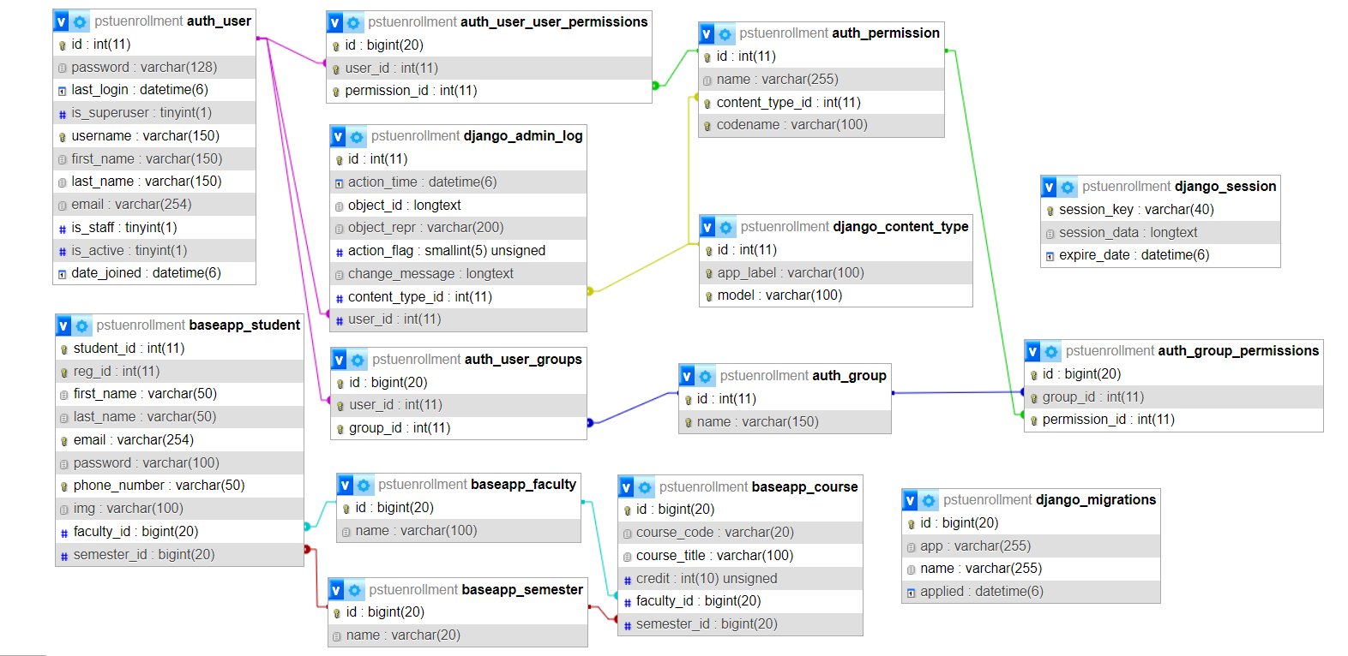

Figure : PSTU Enrollment System ER Diagram

## **Summary**

In this chapter, we have covered several topics related to the University Management System of PSTU. Firstly, we discussed the data dictionary and the database management system. We also provided a detailed explanation of the various tables used in the system. Additionally, we have included the symbols and meanings used in the database design. Finally, we have presented the ERD for the system along with a brief description of the same.

# **CHAPTER-5**

# **SOFTWARE DESIGN**

## **Introduction**

In the software design phase of PSTU Enrollment System, we'll convert requirements into a structured software representation. This includes detailing components, interfaces, and necessary data for implementation. The design will guide the development team, documenting architecture, requirements, and design decisions, ensuring alignment with project specifications and industry standards.

## **Overall design**

### **Admin Panel**

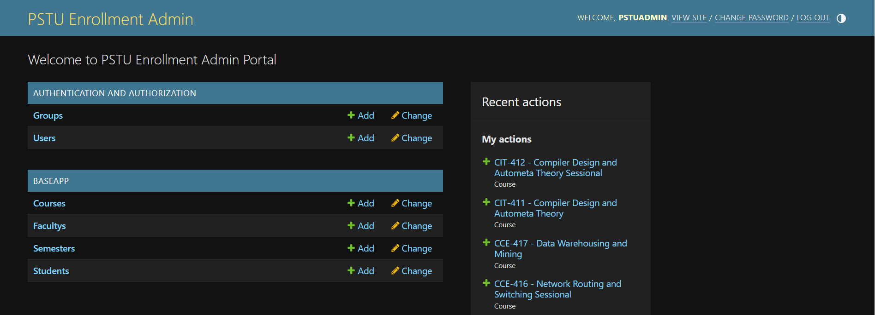

Figure : Admin Panel

### **Student Account Create and Delete**

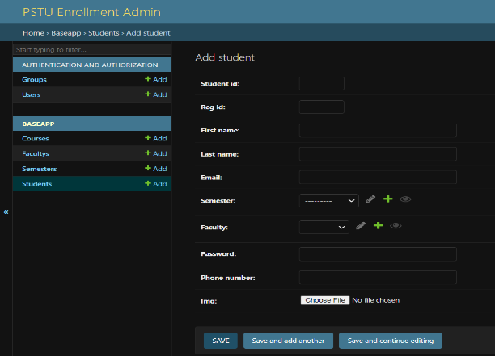

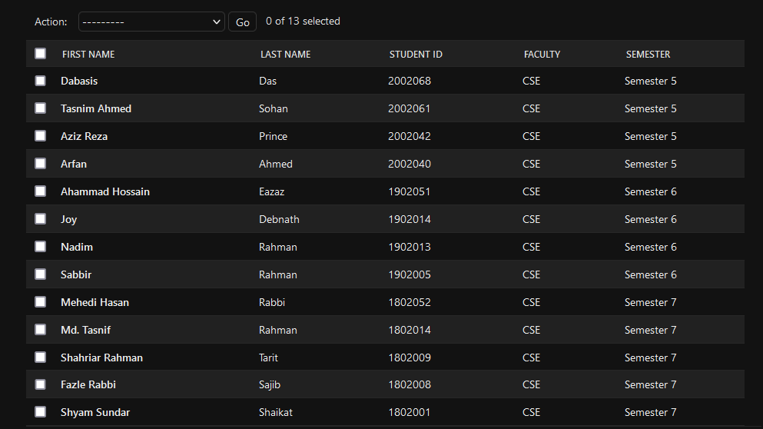

Figure : Student Account Create and Student List

### **Course Add and Delete**

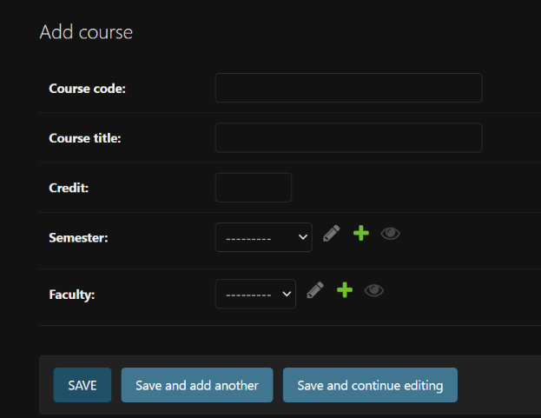

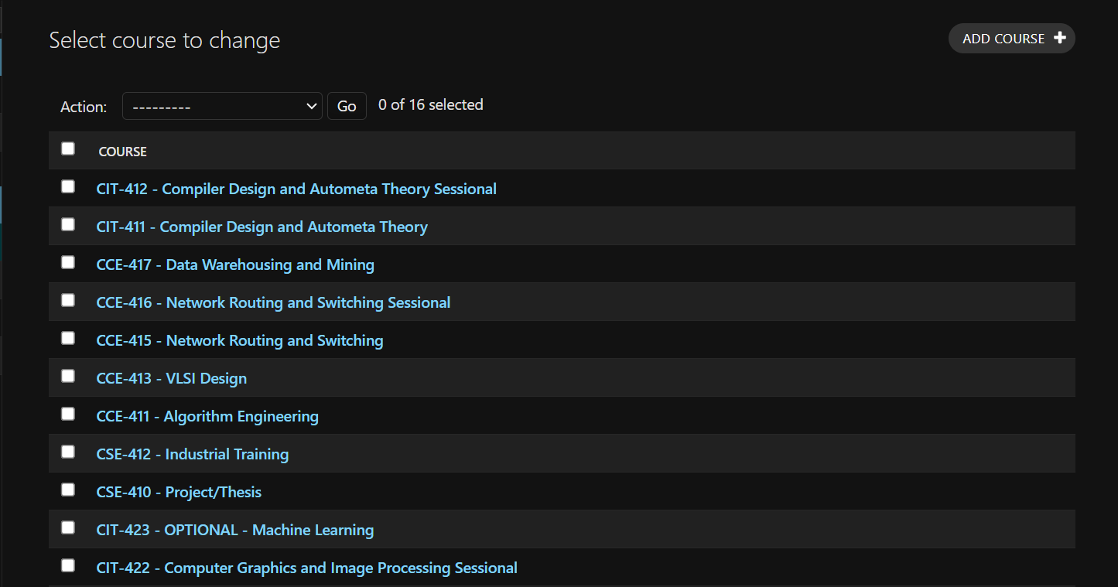

Figure : Course Add and Delete

### **Student Dashboard**

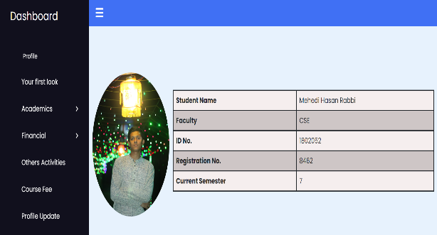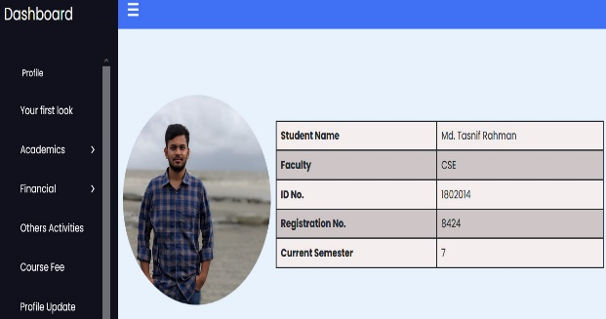

Figure : Student Dashboard

### **Next Semester Course List**

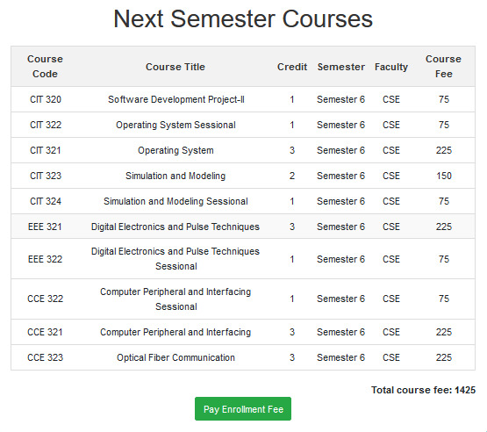

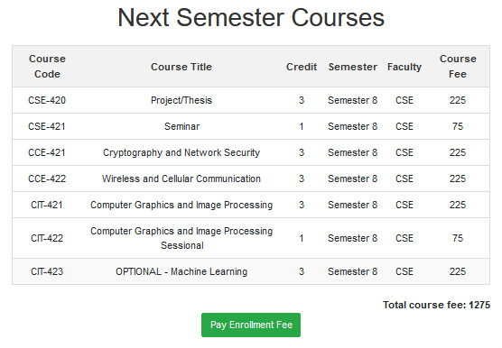

Figure : Next Semester Course List

### **Payment Page Design**

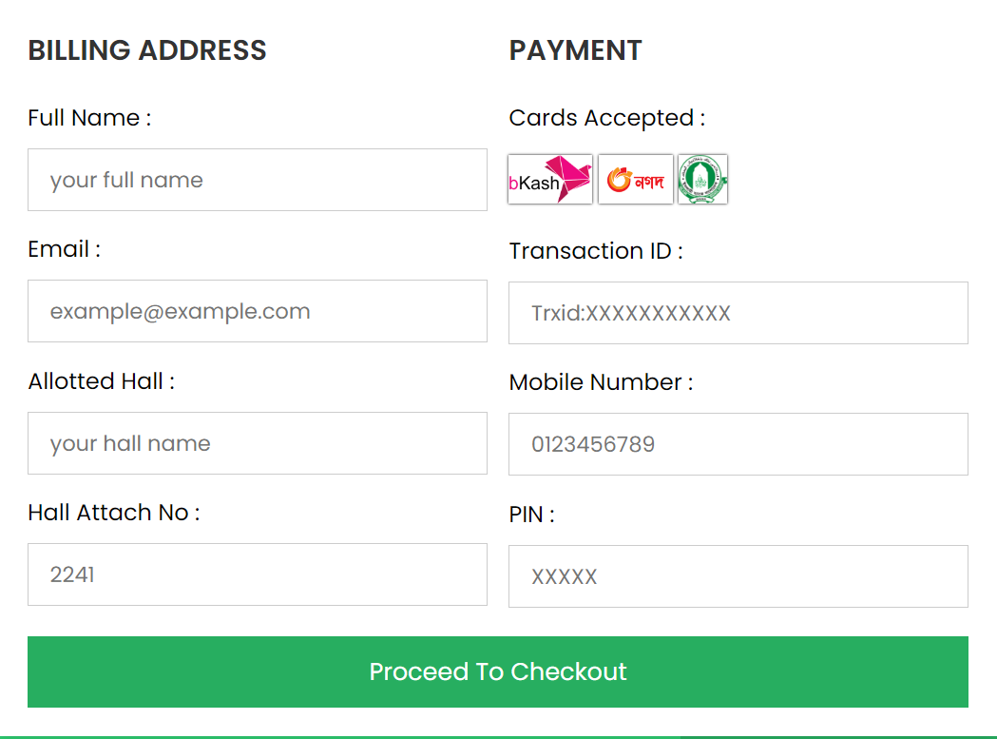

Figure : Payment Page Design

## **Summary**

In this chapter, we have presented the Admin Panel, Student Account Create and Delete, Course Add and Delete, Student Dashboard, Next Semester Course List, Payment Page Design. Through this presentation, readers can understand the relation between System Design and Requirement Engineering, as well as how it affects the Design Techniques used.

# **CHAPTER-6**

# **TESTING AND SEQURITY**

## **Introduction**

Testing and security are vital for the PSTU Enrollment System. Testing verifies functionality through unit, integration, and system tests, ensuring compliance with requirements. Security testing safeguards against unauthorized access and data breaches, employing measures like vulnerability assessments and encryption. Ongoing maintenance plans are crucial for sustaining functionality and security.

## **Research Objective & Development Approach of Agile Methods**

In this chapter, we explore the topic of testing and security in the context of our project. The exploratory research conducted aimed to provide answers to two key questions: Firstly, what agile testing deployment approaches are being used by researchers and software companies? Secondly, what is the formal process used to insert testing in agile development teams? Based on the studies surveyed, we can observe that the testing deployment approaches used in agile development teams tend to be influenced by the types of extreme programming methodologies being implemented. One important aspect of testing in this context is the use of regression tests to ensure that any new features added to the software are thoroughly tested and do not affect the behavior of other features. In addition, the survey revealed several characteristics of testing in agile development:

* Automation of testing - this involves the use of automated tools and scripts to conduct tests and detect errors more efficiently.
* Integration testing - this involves testing individual components of the system as well as the system as a whole to ensure they work together as intended.
* Continuous integration testing - this involves conducting tests on a regular basis, often daily or weekly, to identify and address any issues that arise quickly.
* Tester as a team member - this involves including testers as part of the development team to ensure that testing is integrated into the development process from the beginning.

### **Test Automation**

Test automation is the process of automating test cases and executing them using automation tools or software. There are several phases involved in test automation that help ensure the quality of the software product. These phases include:

* Test Planning: This phase involves creating a test plan that outlines the test objectives, scope, and requirements. It also includes identifying the types of tests to be executed, setting up the test environment, and selecting the appropriate testing tools.
* Test Development: In this phase, test cases are developed based on the requirements and specifications of the system. The test cases are created using automation tools and are designed to be executed repeatedly.
* Test Execution: Once the test cases are developed, they are executed using the automation tool. The tool simulates the actions of a human tester and runs the test cases. The results of the test execution are then compared to the expected results to determine if the software meets the requirements.

### **Regression Tests**

Regression testing in the PSTU Enrollment System verifies that existing functionalities remain intact after system changes. It involves re-running functional and non-functional tests to ensure continued correct performance despite modifications to the system or its environment.

## **Summary**

In this chapter, the focus is on the actual outcomes of the entry system. During testing, various defects were identified, which aided in error recovery and made the software more efficient and smoother. The debugging process was performed step-by-step on all data, including owner, admin, and user.

# **CHAPTER-7**

# **CONCLUSION**

## **Introduction**

The conclusion section summarizes the findings and outcomes of the study, and provides recommendations for future work. It is an important section as it helps to tie all the pieces of the research together and highlight the key points that have been made throughout the study.

## **Project Outcomes**

The PSTU Enrollment project resulted in the successful development of a comprehensive university management system using the Django framework. It incorporated essential features such as user authentication, course management, student enrollment, and profile management. Various testing techniques were applied to ensure functionality, reliability, and security. The system was designed with a user-centric approach, focusing on usability and accessibility. Overall, the project outcomes reflect the successful application of software engineering principles and methodologies to develop a robust and user-friendly university enrollment system.

## **Future Works**

Some of the future works of the project are the following:

* Integration of a payment gateway to facilitate online transactions
* Implementation of a transaction history feature for tracking financial activities
* Incorporation of OTP verification for student logins to enhance security
* Exploration of hosting options to ensure optimal performance and availability
* Implementing a new user role specifically for faculty administrators within the system

## **Summary**

In conclusion, the PSTU Enrollment project successfully applied software engineering principles and agile methodologies to enhance administrative efficiency and communication. Future work includes implementing a faculty-wise website and refining user interfaces for an improved experience. Overall, the project demonstrates effective project management and collaborative development efforts.

# **References**

**Books:**

1. Silberschatz, A., Korth, H. F., & Sudarshan, S. (2019). Database System Concepts (7th ed.). McGraw-Hill Education.
2. Ramakrishnan, R., & Gehrke, J. (2003). Database Management Systems (3rd ed.). McGraw-Hill Education.
3. Martin, R. C. (2008). Clean Code: A Handbook of Agile Software Craftsmanship. Prentice Hall.
4. Sommerville, I. (2015). Software Engineering (10th ed.). Pearson.

**Website:**

1. Django documentation, <https://docs.djangoproject.com/en/5.0/>
2. Drawing E-R Diagram, [https://www.mysql.com/products/workbench](https://www.mysql.com/products/workbench%20)
3. SQLite documentation, <https://www.sqlite.org/docs.html>
4. Django Web Framework (Python), <https://developer.mozilla.org/en-US/docs/Learn/Server-side/Django>